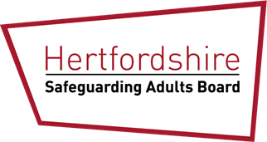
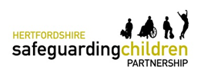

The Science of Wellbeing
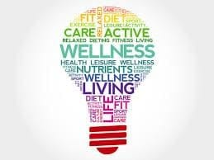

Wellbeing Course - Open to both Children and Adult Practitioners

FREE OF CHARGE FOR EVERYEONE*

Taking time for yourself

During these challenging times brought about by COVID-19, everyone needs to ensure they take time for themselves, to help build resilience and manage the challenges we face in both work and our personal lives.

The HSCP and HSAB are offering sessions for all practitioners working with families and children to attend one of these wellbeing courses.

Facilitator: Adrian Bethune
Adrian Bethune is a part time primary school teacher, the Education Policy co-lead at the Mindfulness Initiative and founder of Teachappy. In 2012, he was awarded a ‘Happy Hero’ medal by Lord Richard Layard at the House of Lords for his work on developing wellbeing in schools. In 2015, he was invited to speak at the Action for Happiness event, Creating A Happier World, on stage with the Dalai Lama.

How the science of wellbeing can improve your life
In this session, Adrian Bethune, will introduce you to the science of wellbeing (sometimes known as positive psychology), sharing the evidence of what works and giving practical ideas for applying it to their lives. It will cover rewiring the negativity bias, maintaining perspective, mindfulness, generating positive emotions and gratitude.

14 December 2020, 1:30pm to 3:30pm
15 January 2021, 9:30am to 11:30am
3 February 2021, 1:30pm to 3:30pm
17 March 2021, 9:30am to 11:30am
All sessions are via MS Teams

For bookings, please visit the HSCP website or contact
Jane Savage

*These sessions are free of charge for all attendees, but there will be a charge for non-attendance.

