Referral form  Online Healthy Families group programme  Hertfordshire  The online Healthy Families programme is an early intervention supporting families with children under 5 years to adopt healthier lifestyles. |  | 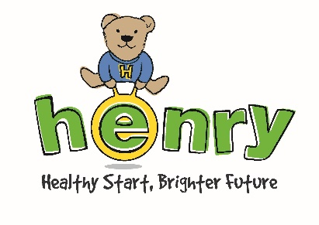
A structured 8 week programme (including a family time session), the group programme applies a solution-focused and strengths-based approach to build parents’ skills and confidence in maintaining a healthy lifestyle.
Please note that all referrals must be made with the consent of the family. You will be asked to confirm that you have gained the parent(s)’s consent at the end of this form and they need to fit the eligibility below:

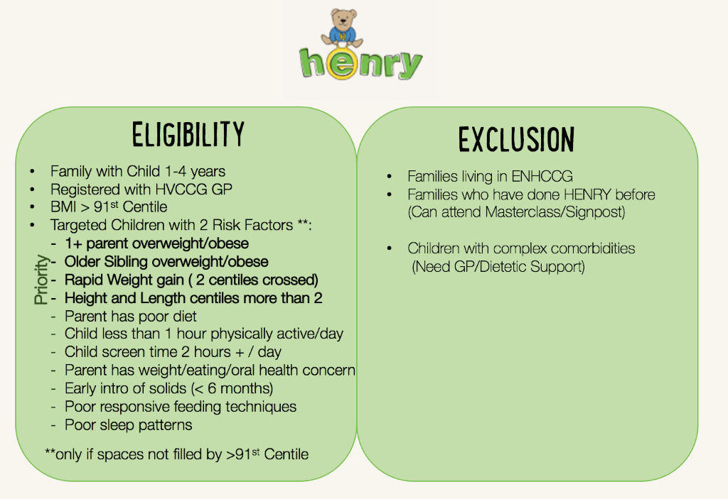

Please provide some details about the family:
Name of parent(s) or carer(s):
Name(s) and age(s) of children:
(n.b. the family must have at least one child under 5 years)
Address:
Contact phone number(s):
Email address:
Does the family have any language, mobility or communication needs we should be aware of?
Why do you think this family could benefit from the Healthy Families group programme?
(Please give as much detail as you can)
Are there any medical or social details we need to know?
Are the family on a child in need or child protection plan?
Is the child a locked after child?

Referrer details:
Name of referrer:
Role:
Address:
Contact phone number(s):
Email address:
HOW TO REFER:

Once you have gained the parent(s)’s consent to refer them to the HENRY programme at BeeZee Bodies and have signed below to confirm this, please complete this form and return it according to the instructions below:
 |  |  | Alternatively,
- Email to beezee.bodies@nhs.net  - https://beezeebodies.com/refer-a-client/ |  |  | Call BeeZee Bodies on 01707 248648
We will use your information to process this referral and to contact you about future HENRY programmes
If you wish to discuss this referral (or how to send it) please ring call BeeZee Bodies 01707 248648
PRIVACY NOTICE & DATA PROTECTION
You are submitting this referral form to BZ Bodies Ltd. BZ Bodies will use the personal information here to refer the parent to the Healthy Families programme in Hertfordshire. We will also use anonymous data from this form to evaluate parent engagement with the HENRY programme.
All information will be kept securely and confidentially by BZ Bodies. We retain referral forms for up to 3 years after receiving them. If you or the parent would like to know more about how BZ Bodies uses and protects your personal information, and your rights, please contact us using the details at the foot the page.
By submitting this form, you affirm that you will handle the client’s personal information with due respect to their privacy, data security and rights in accordance with the relevant regulations. If you need to retain a copy of this form, or any information herein, please note that it is your or your organisation’s responsibility to ensure that the client is informed of this and that their information is held securely in compliance with the relevant data regulations.
☐ Please tick here to confirm that you have gained the client’s informed consent for their personal information to be shared with BeeZee Bodies, and that you have read and understood the statement above.
Name of referrer: |  |  |  | Date:

