[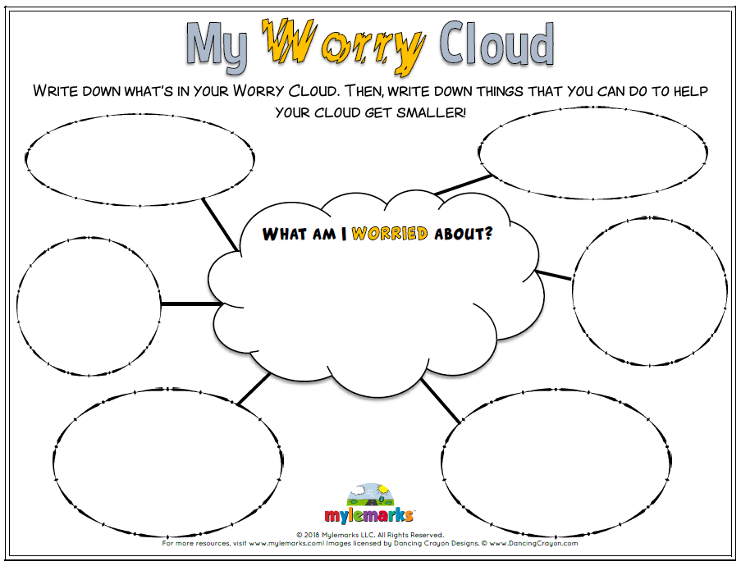](https://www.google.co.uk/url?sa=i&rct=j&q=&esrc=s&source=images&cd=&ved=2ahUKEwiDuNOO6_DiAhVQRBoKHeepA9MQjRx6BAgBEAU&url=https://www.mylemarks.com/store/p167/My_Worry_Cloud.html&psig=AOvVaw1jugipJrL09Zzq6431ZfBQ&ust=1560871904500297)