
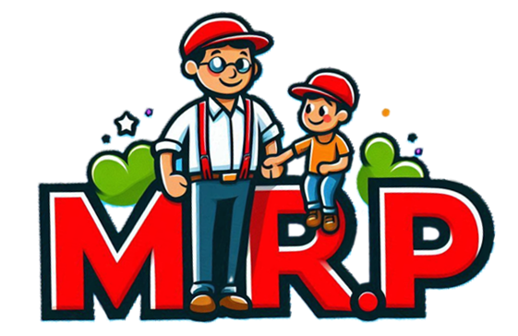

Male Role Model
Programme
“Male Led,
Child Focused”

The Mr Programme !! Exploring what
a positive male role model looks
like for children in today’s modern world.

Face to Face (from 6:00pm – 8:00pm):

- Tuesday 10TH March 2026 until Tuesday 28th April

Greenhills Site (IFST)
Tenzing Road
Hemel Hempstead
HP2 4HS


For more information, or to refer someone or yourself, scan the QR below:


Logo inspired by Noah (Nephew) and Nathan (Uncle)
If you have any further questions or queries,
please email us at ifst.dacorum&stalbans@hertfordshire.gov.uk or call us at 01442 453842.

