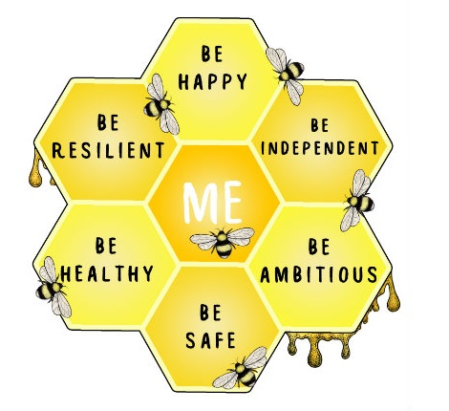

Dear……………

My name is...................

I work with your Social Worker. I am going to be working with you to get to know you and to talk about your wishes and feelings.

We will be completing lots of fun games and activities together.

We will be speaking to each other over video call because I can’t come to your home or school at the moment.

I look forward to speaking to you soon.

From………………

