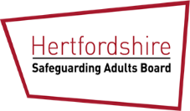
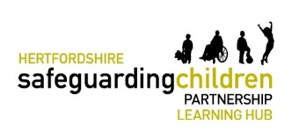

Violence Against Women and Girls (VAWG)
Learning Hub Newsletter: May 2023
In this newsletter:  - Dates/times of Learning Hubs  - The Trainers  - VAWG | The Hertfordshire Learning Hubs  The Learning Hub is an important two-way feedback loop between front line practitioners and the Strategic Safeguarding Partnership/Board, ensuring learning on priority local issues is shared and acted on at all levels in a timely way.  The Learning Hub in June 2023 are on the VAWG and are aimed at all professionals working with adults, children and families.
What We Do - Beacon (hertfordshirebeacon.org)  Hertfordshire Safeguarding Children Partnership  Call Children’s Services 0300 123 4043 if you are concerned about a child’s safety.  NSPCC – Report Abuse  Call on 0808 800 5000  Email: help@nspcc.org.uk  Hertfordshire Safeguarding Adults Board | Hertfordshire County Council  If you have an adult safeguarding concern, call 0300 123 4042. | - Dates/times for Learning Hubs  All sessions will last for 2.5 hrs, with a comfort break.  5 June 2023 – 2pm via MS Teams  7 June 2023 – 2pm Herts Development Centre, Stevenage *  12 June 2023 – 10am via MS Teams  20 June 2023 – 10am via MS Teams  22 June 2023 – 2pm via MS Teams  Please visit our website to make a booking  * This session is face to face only.  - The Trainers  Beacon  Beacon is Hertfordshire’s Victim Care Centre and is staffed by professionals from both Hertfordshire Constabulary and Catch 22, an independent organisation commissioned to support victims of crime in Hertfordshire. Beacon’s primary focus is to help people cope and recover from your ordeal.  Holly Burton/Bianca Moreira – HCC Strategic Partnership Team  Holly and Bianca, Adult Care Services, Commission and Development Officers, will cover Hertfordshire’s strategic approach to VAWG.  - VAWG  Sessions will include:  The session will include:  - Overview of Beacon, including remit, referrals pathway, support provided  - Harmful Sexual Behaviours: delivered by a Children’s ISVA, covering language, technology, school culture, case study, etc.  - Harmful Sexual Behaviours: delivered by an Adult Sexual Violence Specialist, covering misogyny, how we contribute to rape culture, systemic issues, case study, etc.  - Lived experience talk from a sexual violence survivor  - How best to support survivors and how we can keep women and girls safe e.g., safety planning, specialist organisations, managing disclosures, challenging everyday sexism.  - Hertfordshire’s approach to VAWG  - Further Reading and Resources  Ending Violence Against Women and Girls – United Nations  Forward – Key Facts about VAWG

