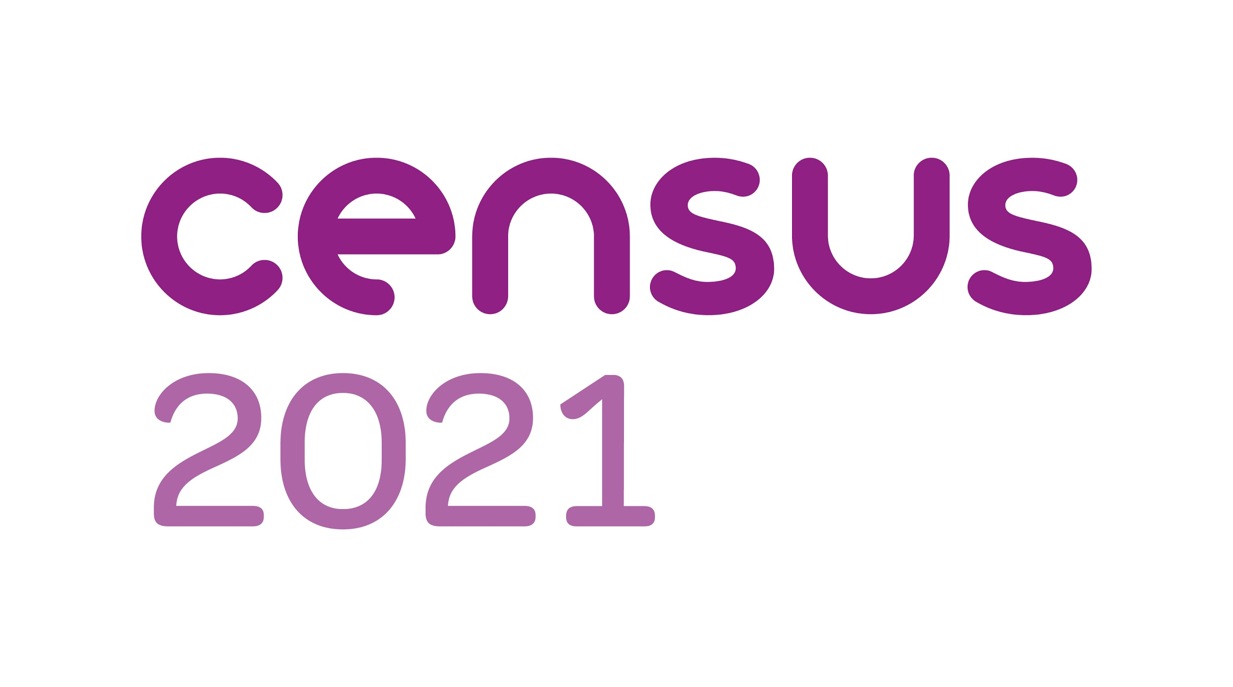
HELPING OTHERS COMPLETE THE CENSUS ON 21 March
Some people in our community may need support in completing their census. As a valued member of the community we are asking you if you would lend a hand by asking people you know a few questions and sharing with them what support is available.
QUESTIONS TO ASK
- Have you had your census letter? These have already started to arrive
- Do you need any help to complete it?
HELP AVAILABLE
- There’s lots of help available including the option to have a paper questionnaire.
  - FREEPHONE helpline - you can request a paper questionnaire or they can complete the questionnaire for you whilst you are on the phone - They can even help in other languages 0800 141 2021
  - LOCAL CENSUS SUPPORT CENTRE - The South Hill Centre, Cemetery Hill HH HP11JF 01442 234728 phone to discuss what support you need
  - ONLINE completion - using the code on your letter You can do this as soon as you get your letter. Answering the questions based on where you will be on 21 March. There is lots of online help and guidance including in other languages - takes about 10 minutes per person depending on how many are in your household
  - ASK A FAMILY MEMBER/FRIEND - they can do it for you/with you
  - FIELD OFFICERS - they will knock on your door and offer support if you haven't completed the questionnaire. They can give you a paper questionnaire or direct you to the support available. They will have an ID badge and be wearing a branded HIVis waistcoat.(see separate visual).

WHY IS IT IMPORTANT TO BE A PART OF CENSUS?
- The census is a survey that happens every 10 years
- It’s a legal obligation that everyone takes part
- It gives the most detailed information we have about our society
- It’s used by the government and Local Authority to Shape policy, Allocate resources to build houses and schools, Plan services like roads & transport & Monitor equality
- It’s also used by charities and businesses to help with decision making and fundraising
YOUR DATA IS SECURE
- Before any statistics are published, all personal details like your name and address are removed
- The data collected is protected by law and can not be shared with anyone, not government departments or private companies. Which gives peace of mind to anyone concerned about completing it
- The information remains anonymous for 100 years kept safe for future generations used by genealogists ancestry and other sites

FOR MORE INFORMATION VISIT www.census.gov.uk

