CHEXS Summer Newsletter 2020
Covid-19 Special
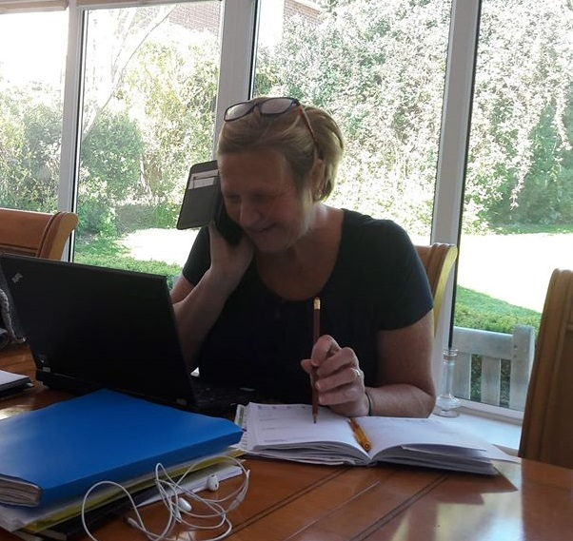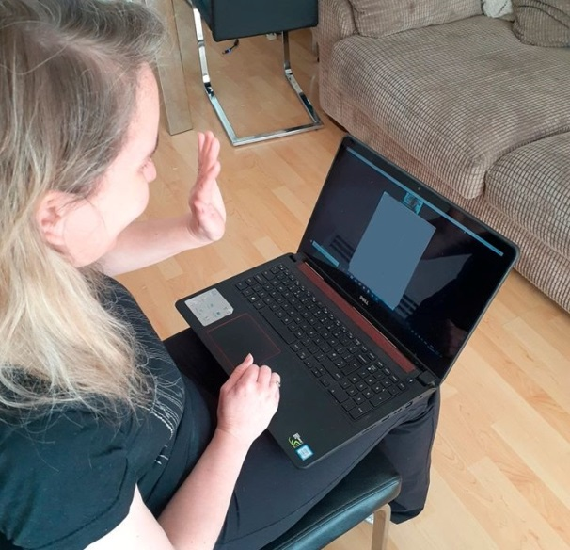
CHEXS are still here to support you in these uncertain times.
- Family Support 1:1 sessions
  - 26 families contacted last week with support and advice
  - 22 Foodbank parcels distributed in the last 3 weeks
- Self Esteem team continue to mentor and support the children and young people we work with.
  - 140 children contacted with support and advice last week
  - 6 video calls last week continuing our amazing mentoring sessions.
- Links to home learning resources given,
The CHEXS team are available to speak to for help, support and advice.
CHEXS main email - admin@chexs.co.uk
Main Phone number - 07970 498966
Family Support Lead - FSL@chexs.co.uk
Self Esteem Team Lead - juliec@chexs.co.uk
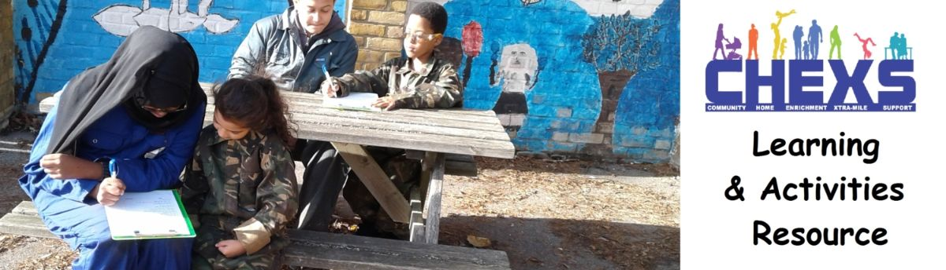
Learning and Resource Webpage
CHEXS learning and Resource page is continually updated to include new links that are becoming available.
We have categories for:
• Secondary aged Young People
• Primary Children and younger
• Games and activities for any ages
• Awards to try
• Internet safety videos to watch together
https://www.chexs.co.uk/o…/learning-and-activities-resource/
We will be looking at our recommended resources in more detail once a week on our Facebook page.
Please Like and follow our page to see more information and updates.

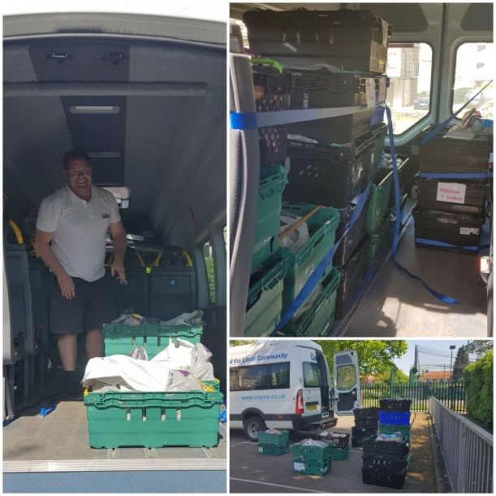
Funding Awarded April 2020
A massive thank you to Hertfordshire Community Foundation for their funding to CHEXS during this difficult time.
CHEXS are now working in partnership with the Foodbank and Holdbrook primary school to further support our community during the current crisis.
The coming months will compound our existing communities needs.
These issues are going to have a huge impact on our wellbeing for months and years after this current crisis has passed.
The additional funding we have been kindly awarded will enable CHEXS to increase our resources, enabling us to do everything within our networks, resources and know-how to be here to help both during and after this crisis passes.
https://www.hertscf.org.uk/…

CHEXS Online Grow competition Launched – 2020
On the 17th April CHEXS launched its new ONLINE Grow Club. An idea thought of by one of our Leadership team students.
The competition is open to ANYONE who would like to take part and its so easy to get involved.
The rules are simple...
It’s so easy to enter.....all you have to do is:-
1. Email us at admin@chexs.co.uk to register
2. Follow the instruction sheets we send out to you.
3. Send us some picture updates from time to time with how you’re doing . They'll then be added to our Facebook event page.
The winner will be judged at the beginning of July - good luck to you all!
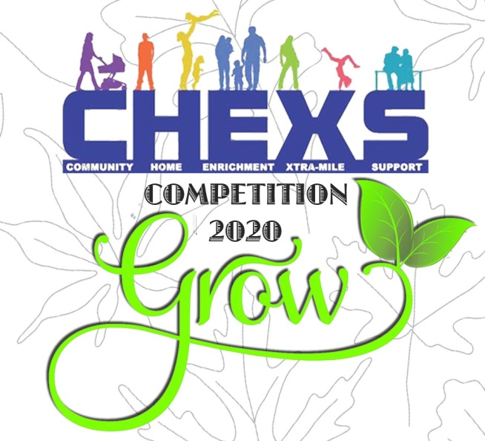
Fundraising for CHEXS
A HUGE thank you to Lee for the amazing fundraising work you did for us at the Cambridge marathon last month dressed as a dinosaur.
He raised a whopping £856.75 for CHEXS
This fantastic fundraising money will be going toward the charities amazing work such as Food bank deliveries, Family support and remote mentoring sessions during the Covid-19 crisis.
If anyone would like to donate to CHEXS, no matter how large or small it would be very much appreciated (and can be done through our Facebook page very easily) - this is an incredibly tough time for all charities and your donations can make a real difference.
Thank you.
Karen our Outreach Worker
It is with sadness that we announce that our Outreach worker Karen has left CHEXS due to personal circumstances. Karen has been awe-inspiring with the work she has done during her time with CHEXS, firstly as a volunteer, then as an employee.
Karen will always be part of the 'CHEXS family' and there will always be a warm welcome for her, she is held in such high regard by colleagues, the families that you worked with on a daily basis, and the Trustees for the Charity. We are all exceptionally grateful for all that you have done as an inspirational member of the CHEXS team.
It goes without saying that we wish Karen all the very best for the future.
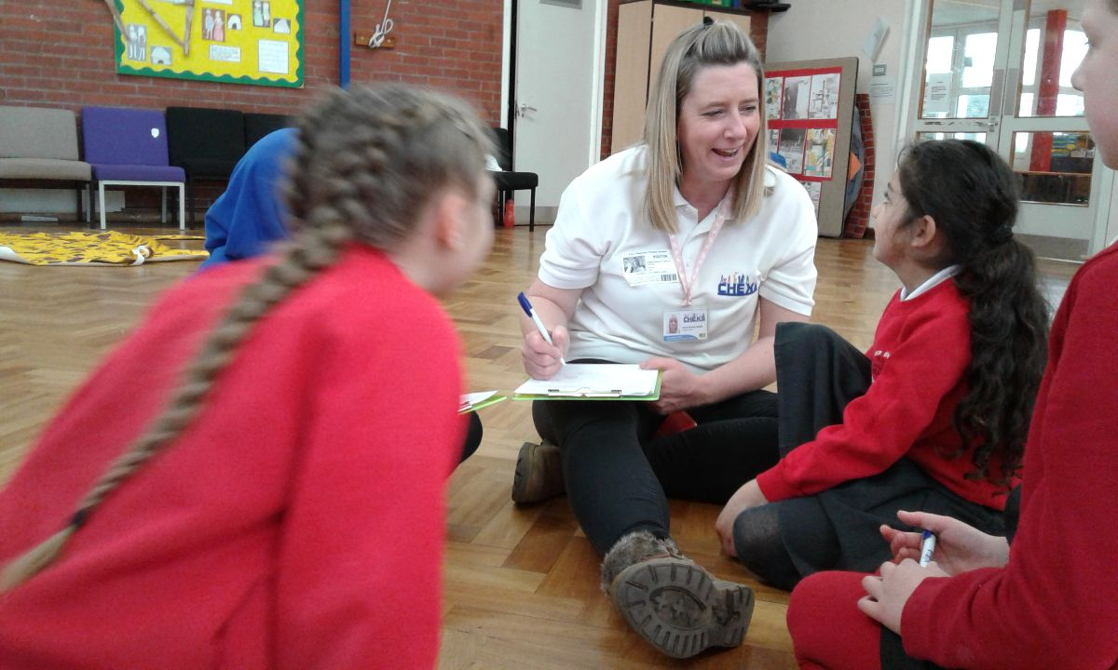
Karen's 'The Craft Room' CHEXS Fundraiser
A HUGE thank you to Karen for setting up a fantastic fundraiser for CHEXS. She has been painting rocks for the community to hide locally since lockdown began and is now asking for donations to CHEXS.
She has already raised £115 for us - thank you so much Karen and the local community for your kind donations and support at this difficult time.
To join the fun go to The Craft Room.
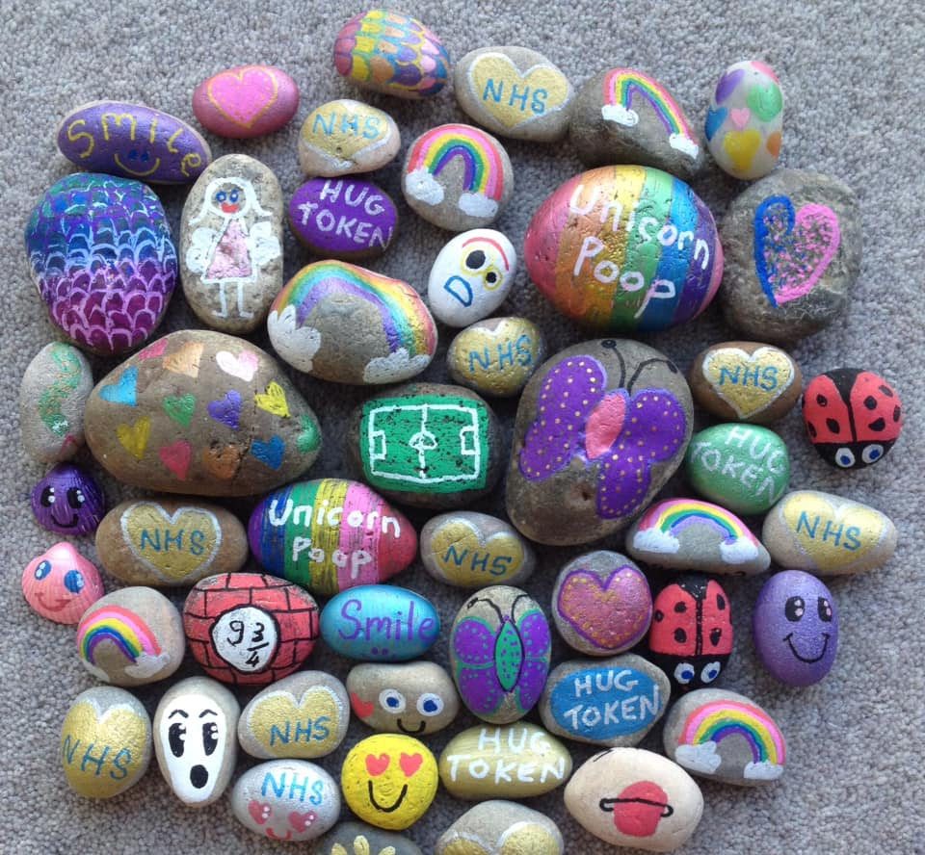

CHEXS and how you can support us..
Fundraising
Sponsorship
Volunteering
Donating
Joining our Virtual Grow Club
Following our social media pages and sharing any posts / articles
For more information, please contact us on admin@chexs.co.uk
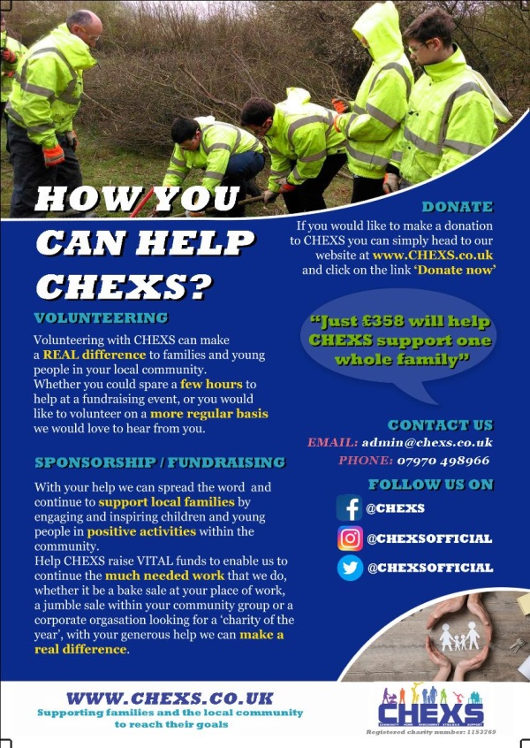

Copyright © 2019 CHEXS Registered Charity 1153769
All rights reserved.
Our mailing address is:
CVSBEH Community Skills Hub 59 Pavilion High Road, Waltham Cross EN8 7JU
Contact us at admin@chexs.co.uk Telephone: 07970498966

